**XJTLU Entrepreneur College (Taicang) Cover Sheet**

|  |  |  |
| --- | --- | --- |
| Module code and Title | **DTS201TC Pattern Recognition** | |
| School Title | **School of AI and Advanced Computing** | |
| Assignment Title | **Final project** | |
| Submission Deadline | **23:59, 31st Dec.** | |
| Final Word Count |  | |
| If you agree to let the university use your work anonymously for teaching and learning purposes, please type **“yes”** here. | |  |

I certify that I have read and understood the University’s Policy for dealing with Plagiarism, Collusion and the Fabrication of Data (available on Learning Mall Online). With reference to this policy I certify that:

* My work does not contain any instances of plagiarism and/or collusion.  
  My work does not contain any fabricated data.

**By uploading my assignment onto Learning Mall Online, I formally declare that all of the above information is true to the best of my knowledge and belief.**

|  |  |  |  |  |  |  |
| --- | --- | --- | --- | --- | --- | --- |
| **Scoring – For Tutor Use** | | | | | | |
| **Student ID** | | | |  | | |
|  | | | | | | |
| **Stage of Marking** | | **Marker**  **Code** | **Learning Outcomes Achieved （F/P/M/D）**  **(please modify as appropriate)** | | | **Final**  **Score** |
| **A** | **B** | **C** |
| 1st Marker – red pen | |  |  |  |  |  |
| Moderation  – green pen | | **IM**  **Initials** | The original mark has been accepted by the moderator (please circle as appropriate): | | | Y / N |
|  | Data entry and score calculation have been checked by another tutor (please circle): | | | Y |
| 2nd Marker if needed – green pen | |  |  |  |  |  |
| **For Academic Office Use** | | | **Possible Academic Infringement (please tick as appropriate)** | | | |
| **Date**  **Received** | **Days late** | **Late Penalty** | **Category A** | | Total Academic Infringement Penalty (A,B, C, D, E, Please modify where necessary) _____________________ | |
|  |  |  | **Category B** | |
| **Category C** | |
| **Category D** | |
| **Category E** | |

DTS201TC Classification Demonstration

Project (Individual)

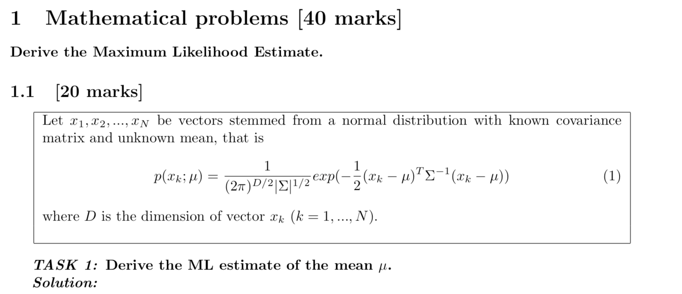

***put you answer here***

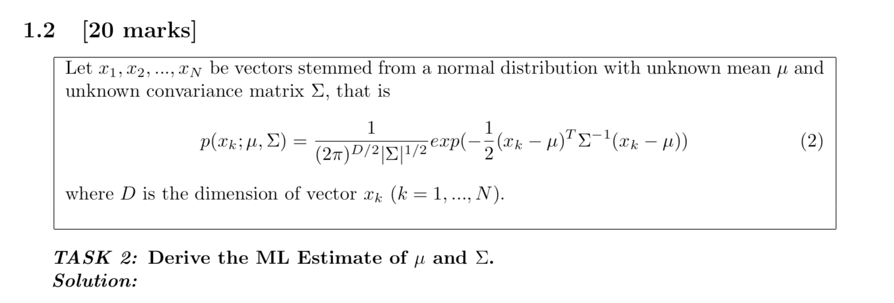

***put you answer here***

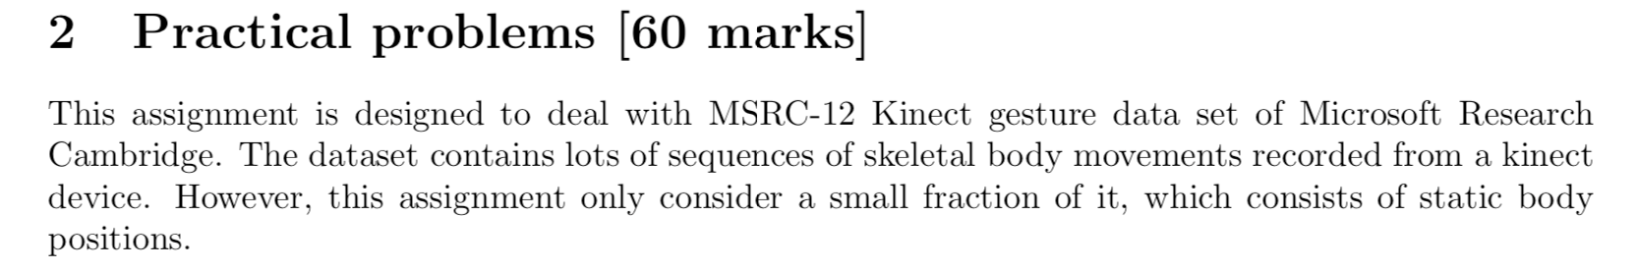

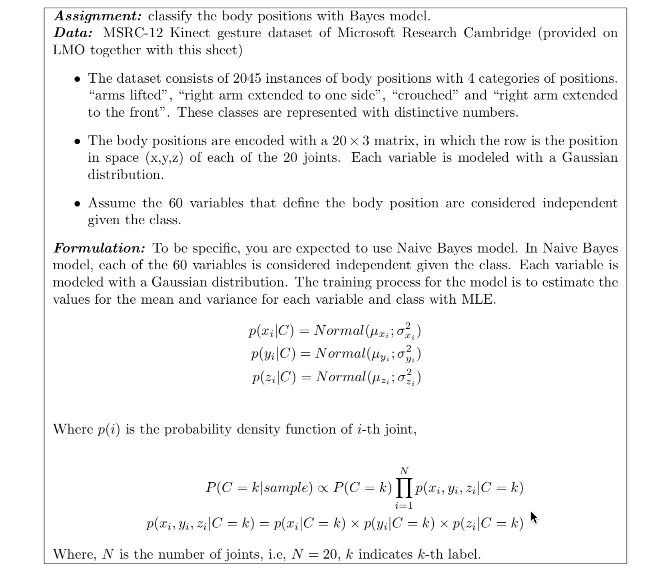

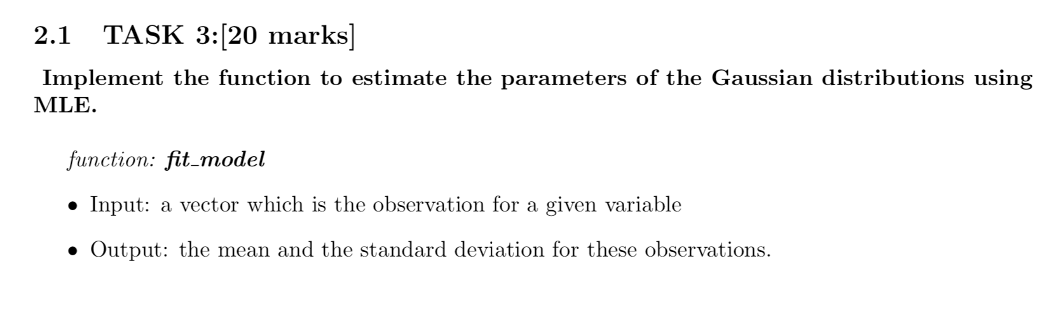

***put you answer here, if you write pseudocode***

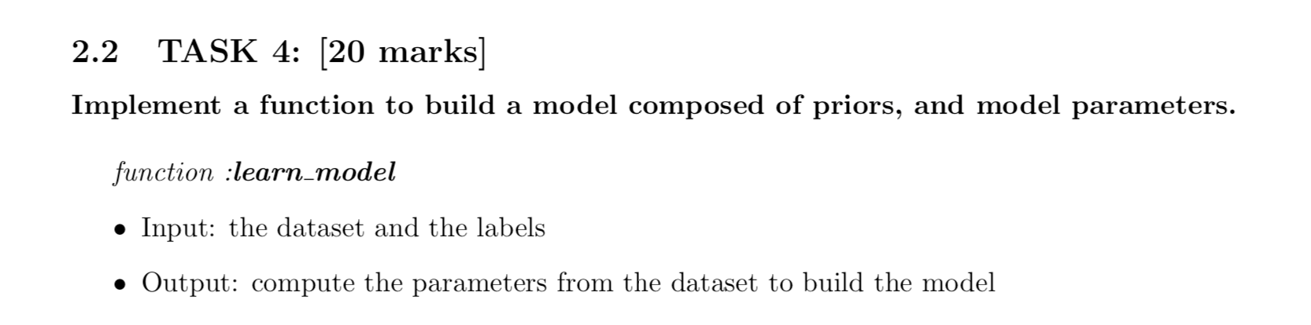

***put you answer here, if you write pseudocode***

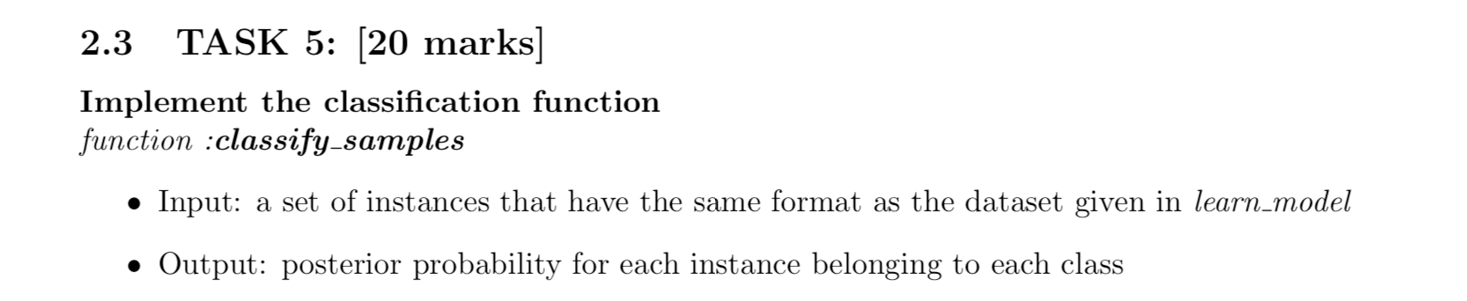

***put you answer here, if you write pseudocode***

